EP408 – Project Report

Solar Orbits

Name: Hardeep Kaur Gill

Student Number: 20705251

Date: 18/12/2023

**Introduction**

It is known in the world of physics education, that there is large discontinuity in the learning process of becoming a practising physicist. In other words, the education a physicist-to-be receives can be distinguished in two phases. Phase one is widely known as the phase where the knowledge is organised in the form of textbooks and well-defined chapters within them. The knowledge is easily comparable to real life phenomena. On the other hand, phase two becomes a bit more chaotic. Upcoming physicists are expected to confront a disorganised physical reality and to make up some kind of order in the form of a new law or principle from the apparent confusion. This gap can be challenging for students who are drawn to physics for its structured mathematical nature and excel at the reasonable tasks of the first phase. The realization that induction is a key activity in practical physics can be disappointing for them.

One way to fill up this gap is to introduce what is known as a “mini-research” problem. The goal of these is to provide students with an intellectual experience that closely resembles that of a researcher. The problem should ideally fulfil several conditions to be considered a “mini-research” problem. In particular, the problem should start with a confusing, yet surprising, observation. The explanation of that observation should not be readily available on textbooks or any other kind of literature. It should be hard enough to baffle a practising physicist and for them to come up with a good explanation easily. A potential solution to this problem should be rich enough to face scrutiny from peers or judges and there should be room for alternative explanations. Lastly, it would be ideal for the mini-research to be completed without excessive demands on the student’s mathematical skills.

The document then provides an example of a mini-research problem that has proven successful for freshmen, upper-level physics majors, and newbie graduate students. The problem is designed to meet the specified conditions above effectively.

**The problem**

Textbooks deal with the topic of motion due to the attractive inverse-square central force law of gravitation or electrostatics in great detail. However, there is a question that a student can come up with while studying this motion in their course: What if the force was just a bit different from the inverse square law? This problem seems to fit the mini-research conditions except for the one that there is too much literature on this question already. According to Arthur’s (1973) observation, there is a slight twist to the initial question imposed that has not yet been considered by people in this field. He also noticed how when working physicists or physics teachers are asked this new question, they hardly answered correctly at all. That new question is: What sort of motion would occur if in addition to the gravitational force there were also a uniform force, constant in magnitude and direction, acting on the particle? More specifically, in the context of this project, we can assume the pressure from the solar wind could as the uniform force acting on a planetary system. The goal is to study the effects of this uniform force on the system.

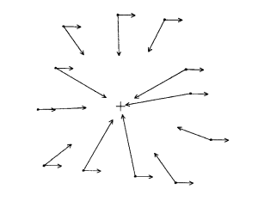

*Figure1: Diagram depicting the forces acting on the planetary system.*

First of all, to visualise this problem better, a python program, called ‘solarWindOrbitForceDiagram.py’ was made to stimulate the force diagram of the planetary system. Pygame was used as the main library to stimulate this easily and with the help of object oriented programming, this stimulation was possible. The result of the stimulation can be found in the ‘Project’ folder under the name ‘solar wind force diagram.gif/mp4’.

Starting with the standard gravitational problem, Newton’s second law is:

$$ma = \frac{-GMm}{r^{2}} (1)$$

Then the equation above cab ne rewritten as a pair of differential equations for the coordinates r1 and r2 (x, y):

$$\ddot{r_{1}}= -\frac{r_{1}}{r^{3}} (2a)$$

$\ddot{r_{2}}= - \frac{r_{2}}{r^{3}} (2b)$

where ${\ddot{r}}_{1}, \ddot{r_{2 }}$ are the acceleration components of the planet, r is the position (broken down to r1 and r2), and GM = 1. To simplify further, it is considered that the direction of the uniform force lies in the x direction, as shown Figure 1. This results in the following equations:

$\ddot{r_{1}}= -\frac{r_{1}}{r^{3}}+k (3a)$

$\ddot{r_{2}}= - \frac{r_{2}}{r^{3}} (3b)$

where k is the magnitude of the uniform force. From a mathematical point of view, the problem is about finding the solutions to equations 3 and how they differ from the solutions of equations 2.

**The solution**

The approach taken to solve this problem emphasized the dynamic nature of Newton’s second law. In other words, by knowing the force function and the values of the current variables (i.e. position and velocity), the new values for state variables can be defined instantly. This can be done by hand, however, it would take a considerate amount of time to find all solutions. So, a computer can be used to do all calculations instead using Euler’s method. An example block diagram depicting the algorithm used to solve the problem is shown below in figure 2 (made using lucid):

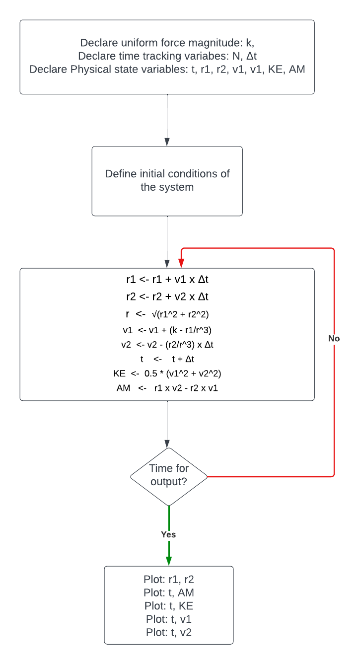

*Figure 2: Block diagram of initial code showing implementation of Euler’s method*

The block diagram establishes the magnitude of the uniform force and the variables that keep track of time. It also shows how arrays should be declared of each physical quantity-variable that described the system. The next block is important, as it defines the initial conditions which will be used to find the subsequent values later on. Also, a loop is implemented that calculates the values of each physical quantity an instant later at a new position using the initial conditions, and then calculates the force at that position. Finally, time is increased by Δt. When the desired time is reached, the loop stops and the physical quantities to be compared are plotted. This should imply that if k = 0, meaning the magnitude of the solar wind force is zero, the orbit should be unchanged.

**The results**

After having everything coded up, the first step is to see what happens when k = 0. Now, logically this would assume that there is no solar wind, thus the orbit should evolve uninterrupted by any external forces. This is accurately shown in the plot below of r2 vs r1:

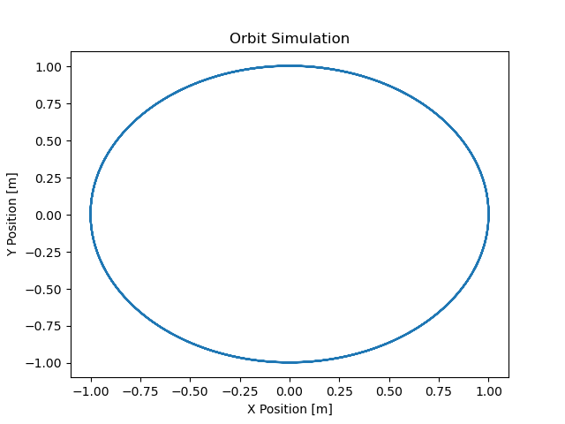

*Figure 3: Unchanged orbit due to lack of uniform force. Only inverse-squared force acting.*

Next step is to change the magnitude of the initial force to be much less than one, keeping in mind it always acts on the x axis with direction to the right. The next figure shows how the orbit evolves if a slight constant force is applied of k = 0.03 N on the planet.

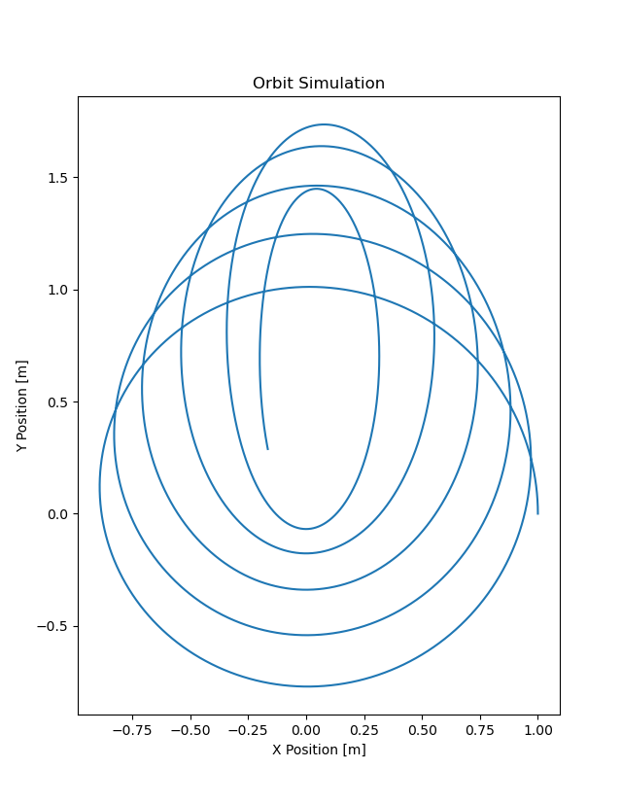

*Figure 4: Initial result of planetary system influenced by solar wind.*

In this folder, you can find the code file under the name “code for figure 6.py”. An animated version of this was also made to use in the presentation. Figure 4 above shows several laps of the orbit and errors are clearly seen dominating towards the end of the running period. The result of this experiment so far has been incredible and give rise to many other questions. The main one being: ‘Why does not the elongation occur in the same direction as the uniform force? Why is it exactly 90 degrees away from that direction?’ There are a number of ways a student investigating this phenomenon can analyse this problem to attempt at a better understanding of it. According to Arthur (1973), 4 distinct methods of analysis are outlined. First of all, an observational attack where the student compares different physical quantities against others to understand how they change. Secondly, a qualitative analysis is also referred to as a more advanced way for the student to understand the system as concepts like ‘effective radial potential energy’. Suggesting that if a particle is displaced from its equilibrium, it results in an oscillating system with some frequency according to the shape of the well. The third type of analysis is the quantitative analysis which focuses on improving the code for more accurate analysis. Lastly, a quantum mechanical approach can also be taken to investigate the properties of this uniform force in the subatomic level by observing how the quantum states of an atom change by placing it in a capacitor and applying slight voltage to it. However, for the purpose of this project, the methods of analysis chosen are the first (observation attack) and the third (a quantitative analysis).

**An Observational Attack**

For this part of the project, different physical quantities where calculated as shown in figure 2. More specifically, they are the position components, the velocity components, the time progression, the angular momentum, and the kinetic energy. These data points were plotted against each other as shown in the upcoming figures.

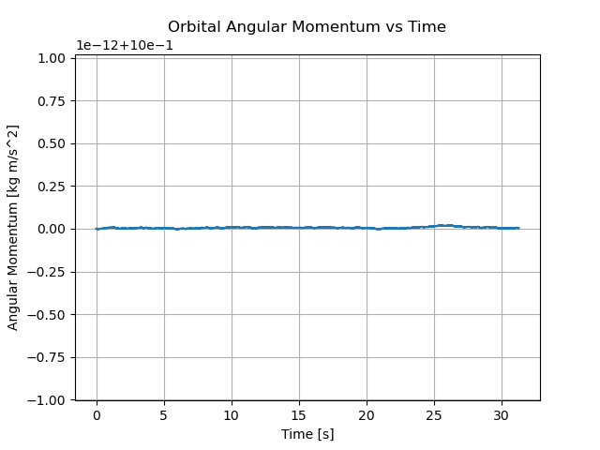

*Figure 5: Angular Momentum vs Time when k = 0. Figure 6: Kinetic Energy of the Solar Wind force vs Time*

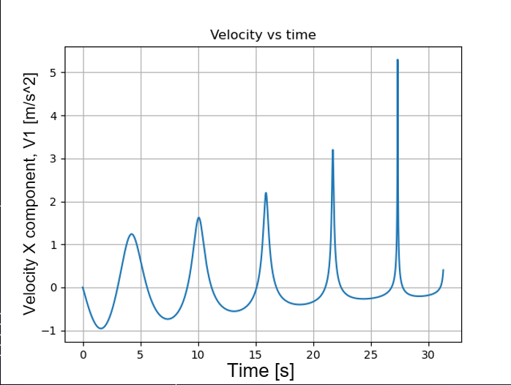

*Figure 7: V1 (x component of velocity) vs Time Figure 8: V2 (y component of velocity) vs Time*

*Figure 9: Angular Momentum vs Time when k = 0.03.*

Figure 9 above shows how the angular momentum of the system changes over time when k = 0. The system seems to have a constant angular momentum of about zero, this is because there are no non-conservative forces acting on the system. On the contrary, if k is applied the graph looks like what is shown in figure 9. It is slowly decreasing as the constant force that is acting on the planet like torque, which in turn decrease the total angular momentum over time. Another interesting conclusion from these graphs is how the total orbital energy of the solar wind force is the kinetic energy alone as it is a non- conservative force thus has no potential energy. Lastly, it is fascinating to see how the solar wind affects the 2 components of velocity. The vertical component is unchanged and conserves its normal periodic behaviour, showing its independence from k. On the other hand, the horizontal component, while still preserving the oscillation part, seems to get shifted upwards as well as changing amplitude as well. All of these differences from the v2 vs time graph must be due to the force that is acting it that direction that is greatly affecting speed in a more dramatic way. The planet seems to withhold the minimum values for longer while the maximum values are achieved only for a brief amount of time. This is in accordance with the knowledge of the circular orbit evolving into an elliptical one over time and that is how the speed values get distributed like that. It is important to note that all these graph above are greatly dominated by error towards the end of the plotting.

**A quantitative analysis**

In this part of the analysis an effort was made to improve the code and reduce the computational errors that seem to overshadow the data points after a certain amount of code runtime. Although the step size can always be decreased to achieve a more accurate stimulation, however this alone it not enough to see the full picture of the orbit evolution due to solar wind pressure/force. A point was made to use RK4 method, which is generally known to be more accurate than Euler’s method, however, the Arthur (1972) outlined how it would make the code a lot more complex while at the same time would not offer the respective insight sought. The paper then suggested a new approach, and that is to scale the time according to the formula:

$dt = r^{2} dτ$ (4)

This resulted in a new set of equations shown below:

${\frac{dr_{1}}{dτ} =v}_{1}r^{2}$ (5a)

${\frac{dr_{2}}{dτ} =v}_{2}r^{2}$ (5b)

$\frac{dv_{1}}{dτ} =-\frac{r_{1}}{r}+kr^{2}$ (5c)

${\frac{dv_{2}}{dτ} =\frac{-r_{2}}{r}}_{ }$ (5d)

${\frac{dt}{dτ} = }_{ }r^{2}$ (5e)

These equations were then implemented using Euler’s method in a new python file called “codeForFigure13.py” and the result of this program is stored in the ‘project’ folder under the name ‘figure 13 from paper.png”. The code snippets of this file are provided below:

*Figure 10: Code snippets for quantitative analysis. First picture shows variable declaration and initial*

*conditions while the second image shows the for-loop implementation of Euler’s method.*

The results from of this program are breathtaking as they show the whole evolution of the orbit and the new periodic motion created due to the introduction of this new uniform force. The figure showing this evolution can be found below:

*Figure 11: The whole orbit evolution due to solar wind.*

An animation showing the trajectory the planet was created using matplotlib’s FuncAnimation function. It was used it separate file called ‘codeForFigure13Animated.py’ and the outcome of this file is saved under the name “figure 13 full.gif”. This animation is probably one of the most important ones made as it shows a crucial property of this orbit. More specifically, the entire motion on figure 11 is cyclic. It starts with a counterclockwise orbit and evolves into an elliptical orbit. At some point, the planetary trajectory unwinds down to a circular orbit, but this time the motion is clockwise and the cycle continues.

**Conclusion**

In conclusion, this project was aimed to bridge the gap between structured textbook learning and the chaotic nature of real-world physics by introducing a mini-research problem. The chosen problem involved exploring the effects of a uniform force, representing the solar wind, acting in addition to the gravitational force on a planetary system. The analysis was conducted using a Python program implementing Euler's method, providing a dynamic visualization of the planetary orbit evolution.

The project showcased the importance of numerical simulations in understanding complex physical phenomena. The results revealed that the introduction of the solar wind force significantly altered the planetary orbit, leading to a cyclic motion transitioning between counterclockwise and clockwise orbits, from elliptical to circular trajectories.

The study also acknowledged the presence of computational errors. Efforts were made to enhance accuracy through a quantitative analysis, adjusting the time step according to the scale of the system.

In summary, the project provided an intellectually challenging research problem. The cyclic nature of the planetary motion in the presence of the solar wind force opened up avenues for further investigations as it raised a lot more questions while trying to answer some others. The use of Python programming and visualization tools added a practical and hands-on dimension to the study, enriching the learning experience for aspiring physicists, like me.

References

* Luehrmann, A. (1974). Orbits in the Solar Wind—a Mini-Research Problem. *American Journal of Physics*, 42(5), pp.361–371. doi:https://doi.org/10.1119/1.1987702.
* Feynman, R.P., Morinigo, F.B. and Wagner, W.G. (2003). Feynman Lectures on Gravitation. *European Journal of Physics*, 24(3), pp.330–330. doi:https://doi.org/10.1088/0143-0807/24/3/702.

‌